Practical 2 - Ecological Networks
Noah Atkin

Task 1. Reproduction of Hengill food web properties.csv
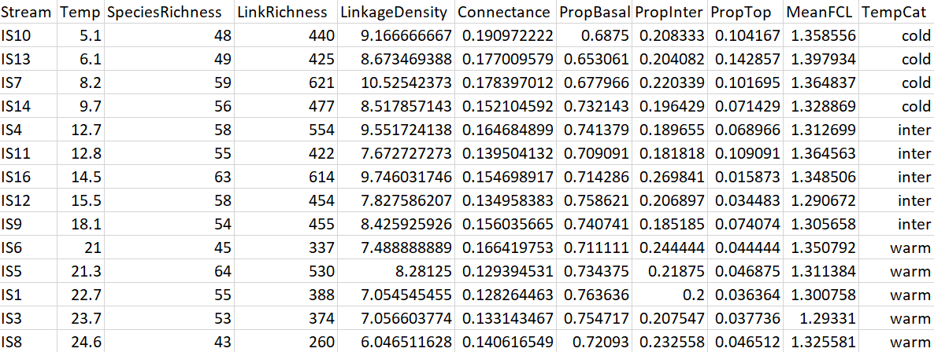
Screenshot of reproduction
rm(list=ls())
library(cheddar)
library(nortest)
setwd(~/Practical2/Practical exercises)
hengill = LoadCollection(Hengill Food Webs)
stats= CollectionCPS(hengill,c(Stream=title,
Temp=temp,
SpeciesRichness=NumberOfNodes,
LinkRichness= NumberOfTrophicLinks,
LinkageDensity = LinkageDensity,
Connectance=DirectedConnectance,
PropBasal=FractionBasalNodes,
PropInter=FractionIntermediateNodes,
PropTop=FractionTopLevelNodes))
stats$MeanFCL= c((mean(ShortWeightedTrophicLevel(hengill[[1]]))),
(mean(ShortWeightedTrophicLevel(hengill[[2]]))),
(mean(ShortWeightedTrophicLevel(hengill[[3]]))),
(mean(ShortWeightedTrophicLevel(hengill[[4]]))),
(mean(ShortWeightedTrophicLevel(hengill[[5]]))),
(mean(ShortWeightedTrophicLevel(hengill[[6]]))),
(mean(ShortWeightedTrophicLevel(hengill[[7]]))),
(mean(ShortWeightedTrophicLevel(hengill[[8]]))),
(mean(ShortWeightedTrophicLevel(hengill[[9]]))),
(mean(ShortWeightedTrophicLevel(hengill[[10]]))),
(mean(ShortWeightedTrophicLevel(hengill[[11]]))),
(mean(ShortWeightedTrophicLevel(hengill[[12]]))),
(mean(ShortWeightedTrophicLevel(hengill[[13]]))),
(mean(ShortWeightedTrophicLevel(hengill[[14]])))
)
stats$TempCat[stats$Temp < 10] = cold
stats$TempCat[stats$Temp > 10] = inter
stats$TempCat[stats$Temp > 20] = warm
sort.stats <- stats[order(stats$Temp) , ]
write.csv(sort.stats, file=stats.csv, row.names = FALSE)

Task 2: Reproduce Triangular food webs.tif

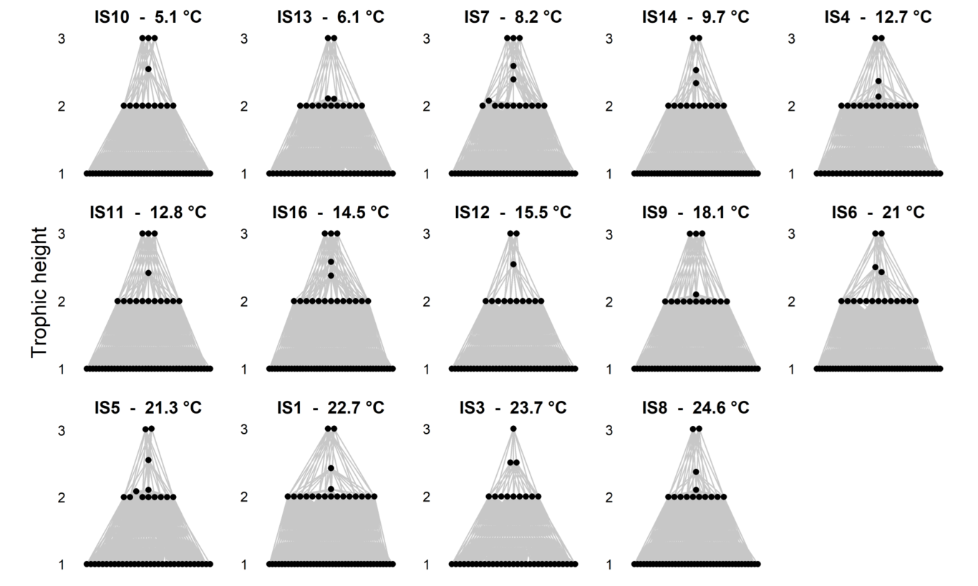
Capture of triangular food web repdroduction
hengill.ord <- hengill[order(stats$Temp)]
tiff(Triangular food webs final.tif, 20, 12, units=cm, res=600, compression=lzw)
par(oma=c(0,4,0,0), mar=c(1,1,2,2), mfrow=c(3,5), font=2)
for(i in 1:14)
{
PlotWebByLevel(hengill[[i]],
pch=16,
highlight.nodes=NULL,
x.layout=narrow,
main= paste(CPS(hengill.ord[[i]])$title, - , CPS(hengill.ord[[i]])$temp, °C),
cex.main=1.25,
font=2,
level=ShortWeightedTrophicLevel,)
}
mtext(Trophic height, side = 2, line = 1, outer = TRUE, font=1, cex=1)
dev.off()

Task 3: Reproduce Food web properties versus temperature.tif
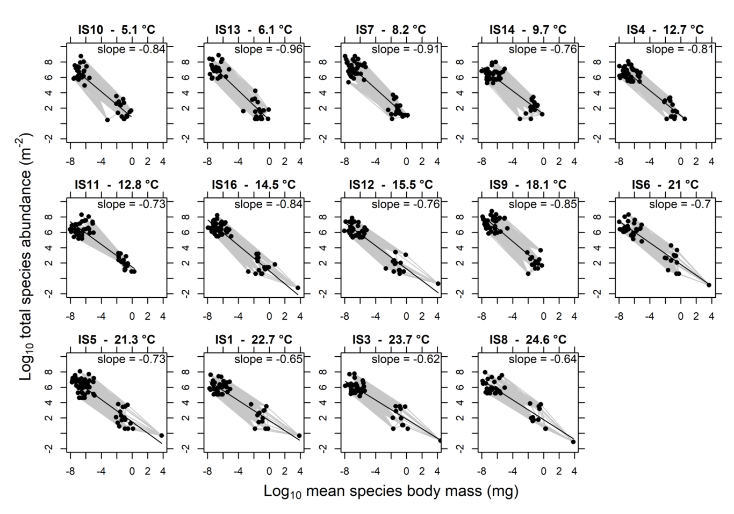
Capture of trivariance
tiff(Trivariate food web noah atkin.tif, 20, 14, units=cm, res=600, compression=lzw)
par(oma=c(2,4,2,0), mar=c(3,1.5,1.5,1.5), mfrow=c(3,5))
for (i in 1:14) {
NvMLinearRegressions(hengill.ord[[i]])
NvMSlope(hengill.ord[[i]])
NvMIntercept(hengill.ord[[i]])

slope1<- NvMSlope(hengill.ord[[i]])
slope1 <- round(slope1,digits=2)
slope1

PlotNvM(hengill.ord[[i]],
pch=16,
ylim=c(-2,10),
xlim=c(-8,4),
xlab= ,
main= ,
highlight.nodes=NULL,
)
title(main = (paste(CPS(hengill.ord[[i]])$title, - , CPS(hengill.ord[[i]])$temp, °C)), line=0.75, cex=1.25)
mtext(paste( slope =, slope1), line=-1, cex=0.75)

model1 <- NvMLinearRegressions(hengill.ord[[i]])
model1
PlotLinearModels(model1)

}
mtext(expression(paste(Log[10]* total species abundance (m^-2*))), side = 2, line = 1, outer = TRUE, font=1, cex=1)
mtext(expression(paste(Log[10]* mean species body mass (mg)^*)), side = 1, line = 0, outer = TRUE, font=1, cex=1)

dev.off()

Task 4: Reproduce Food web properties versus temperature.tif

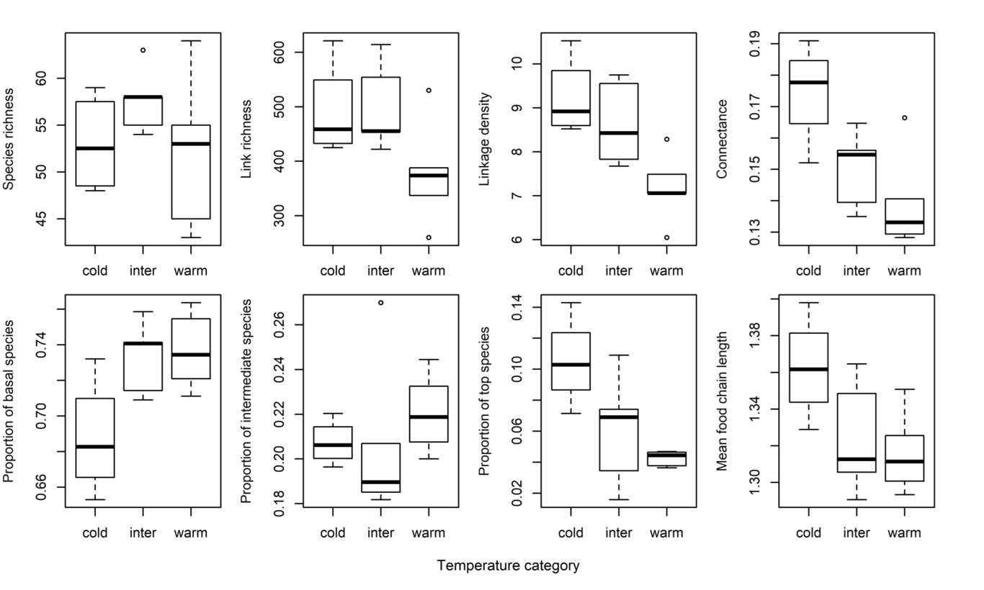
Capture of reproduction
tiff(Food web properties versus temperature.tif, 20, 12, units=cm, res=600, compression=lzw)
par(oma=c(4,2,0,0), mar=c(1,2,2,3), mfrow=c(2,4))
boxplot(stats$SpeciesRichness ~ stats$TempCat, ylab=Species Richness)
mtext(Species richness, side = 2, line = 3, cex=0.65)
boxplot(stats$LinkRichness ~ stats$TempCat)
mtext(Link richness, side = 2, line = 3, cex=0.65)
boxplot(stats$LinkageDensity ~ stats$TempCat)
mtext(Linkage density, side = 2, line = 3, cex=0.65)
boxplot(stats$Connectance ~ stats$TempCat)
mtext(Connectance, side = 2, line = 3, cex=0.65)
boxplot(stats$PropBasal ~ stats$TempCat)
mtext(Proportion of basal species, side = 2, line = 3, cex=0.65)
boxplot(stats$PropInter ~ stats$TempCat)
mtext(Proportion of intermediate species, side = 2, line = 3, cex=0.65)
boxplot(stats$PropTop ~ stats$TempCat)
mtext(Proportion of top species, side = 2, line = 3, cex=0.65)
boxplot(stats$MeanFCL ~ stats$TempCat)
mtext(Mean food chain length, side = 2, line = 3, cex=0.65)
mtext(Temperature category, side = 1, line = 2, outer = TRUE, font=1, cex=0.7)
dev.off()

Describe the effects of temperature on food web properties in the Hengill dataset, with particular reference to the statistics that you performed in the exercise above. Discuss the consequences of these patterns for the organisms within these stream ecosystems.
Temperature has statistically significant effects on the food web properties in 4 of the metrics measured above; namely linkage density, connectance, the proportion of basal species, and the proportion of top species*.
Intuitively, it makes sense that species richness (S) is not affected by temperature as Iceland is not home to many migratory or hibernatory species that would otherwise cause seasonal variation in consumer species richness, and examination of the boxplot indicates that the highest level of species richness is seen in the intermediate temperature ranges. Link richness (L), likewise was not significantly affected by temperature affected by temperature; however interestingly properties of food webs derived from these two non-significant factors were statistically significant. For example, a one way ANOVA test showed linkage density (L/S) was affected by temperature (ρ=0.0146), and linkage density decreased as temperatures increased. This led to a decrease of mean linkage density This link between linkage density and temperature was further backed up by a Tukey test, which showed a significant difference between warm and cold temperatures (ρ=0.0153), however no significant difference between the intermediate temperatures and either extreme. Connectance is another such property directly derived from species & link richness (L/S²) which was significant, a one way ANOVA indicated connectance significantly decreased as temperatures increased (ρ=0.0140), and the results of a Tukey test showed, just like linkage density, the difference was only significant between warm and cold temperatures. Together, the decrease in connectance and linkage density seems to indicate that warming temperatures has significant impacts on food web structure, reducing the complexity of the food web, and perhaps making the food web more vulnerable to pertubations, including extinctions and pest outbreaks (Calizza, Costantini & Rossi, 2015). Extrapolating from this data, it suggests that perhaps one of long term effects of anthropogenic climate change will be weakening of food webs on a global scale to perturbations, especially concerning given one of the defining features of the Anthropocene is the increase of biological invasions on orders of magnitude their previous rate (Kueffer, 2017).
The proportions of species at different trophic levels also appears to be affected by the increase in temperature. ANOVA analyses showed a decrease in the proportion of top species as temperature increases* (ρ=0.0154), and a increase in the proportion of basal species (ρ=0.0273). Both of these are supported by Tukey analyses which showed, like the above tests, that the only significant difference is between warm and cold, and not between intermediate temperatures and either extreme. ANOVA analysis however showed no significant change in the proportion of intermediate species as temperature changes. Warming temperatures have previously been shown to increase the risk of extinction, and this risk is exacerbated in larger species, which offers an explanation as to why these food web differences are seen (Petchey, McPhearson, Casey, et al., 1999). Interestingly, this decrease in the proportion of top species did not lead to a significant difference in food chain length (however the results were very close to statistical significance, ρ=0.0677). The low, if insignificant value suggests if more sites had been sampled, it’s possible significance could have been achieved, and should be examined in detail in the future.
*It’s important to note that a Bartlett’s K test showed significant (ρ=0.00908) departure from homogeneity of the variance for the proportion of top species test; ANOVA is usually robust to these departures as long as the group sizes are equal (O’brien, 1979).

List five pros and five cons of food web approaches for studying global change biology.

Pros.
1. Food web approaches are useful for examining the potential role biological invaders will play in an ecosystem, and the competitive/predatory effect it will have on others within the ecosystem.
2. Food webs are an important educational role for providing laypersons with the importance of secondary/tertiary consumers within an ecosystem e.g. the indirect positive effect the presence of secondary consumers have on producer abundance.
3. Food web can be used to predict species population dynamics in complex ecosystems, and predictions of global changes impacts on food webs can be used to extrapolate future population dynamics.
4. Abnormal increases in temperature and atmospheric CO₂ concentration is one of the defining features of the anthropocene, and with it comes increases in primary productivity. The trophic focused nature allows to extrapolate affects of this increase in productivity on the strength of interactions in a food web.
5. Meta-analysis of food webs on a global scale, and a large temporal scale allows us to examine universal affects of climate change, and predict future global effects.

Cons.
1. Classical food webs focus only on predation interactions between two species. This simplistic focus ignores complex species interactions that can occur in ecosystems, including mutualisms and symbiosis, which are particularly under threat in the 21st century.
2. Particular properties of food webs, such as connectance, treat each inter-node in the food web with equal weight, regardless of the strength of the interaction, which can give a misleading view of true ecosystem functioning. e.g. a consumer species with 2 producer species, producer A comprises 20% of its diet, while producer B comprises 80% of its diet - on a food web the inter-nodes between producer A & consumer and producer B & consumer carry equal weight, despite a much stronger interaction between producer B - consumer.
3. Specific food web properties, such as linkage density, ignore temporal variation in interactions between species, and possible prey switching in different seasons. Likewise, many current food webs are snapshots of an ecosystem in a specific time, rather than taking into account annual changes in the ecosystem. This seasonal variation is particularly important in the future due to the exaggerative effect climate change has on seasons.
4. Similar to 3., spatial variation in an ecosystem is particular important to understanding ecosystem functioning - difference in spatial scale of food web experiments can make similar experiments difficult to compare, and underlying causes of populations changes differ at different spatial scales e.g immigration can be a proportionally more significant factor over a small scale than population growth.
5. Competition between consumers is implicit in food webs, where 2 consumers have links to the same producer, however most food webs do not account for competition among basal species ie resource competition. Resource competition is an important ecosystem dynamic in plants, and will become more important in the future where resources such as water become more variable over time and space.

What are the limitations of the natural warming experiment in Hengill? Describe a controlled mesocosm experiment you might design to address some of these issues?
One of the main problems with natural warming experiments is the inability to isolate the effects of temperature from other factors that may affect food web differences, one of the advantages of the Hengill experiment was that it took place over a relatively small spatial and temporal scale, which removed latitudinal, and seasonal causes of food web differences.
However, the experiment was limited in its ability to control, among other things, non-temperature related weather differences, such as the effect of wind chill on stream temperatures due to differences in cover. pH is another factor difficult to control in natural experiments, and pH varied between hengill streams, ranging from 7.1-8.3. pH can have significant effects on the fitness of different species. Variance of volcanic associated compounds, such as SO₄, can have strong affects on the fitness of individuals, and has also been shown in some species to affect bioaccumulation (Dede & Ozdemir, 2016), which is particularly important in a aquatic ecosystem. Important biochemical building blocks including P-PO₄ varied between sites, which can have wide ranging effects on the food web; and particularly on productivity. The natural experiment in hengill is the experiment begins with pre-existing differences in the food web between sites, which makes it difficult to estimate the rate food web chain differences can occur at; while a mecocosm experiment means you can track differences between initially similar populations constantly over a long period.
Balancing realism with repeatability is the inherent quandary of mecocosm experiments, and it’s the most important thing to bear in mind when designing mecocosm experiments. A lot of these problems can be tackled using a mecocosm experiment, the nutritional differences are the easiest to standardize between enclosures. A good starting point of a mecocosm experiment would be Ullah et al.’s 2018 experiment into the effect of rising temperature and acidity on marine communities (Ullah, Nagelkerken, Goldenberg, et al., 2018). It was a 6 month indoor mecocosm experiment that housed 12 1800L enclosures in a single temperature controlled room. In Ullah et al.’s experiment, the room was compartmentalized into 4 treatments, including a control. For our mecocosm experiment, we will divide the room into three treatments, we will control the temperatures in each of the areas to be the rough midpoints for each of the temperature categories ie 7.5°C, 15°C and 22.5°C. The set difference between each of the treatments allows us to more easily examine any possible linear relationships between food web properties and temperature. This switch of three mecocosms per treatment to 4 also increases the reliability of the experiment, and increases the power of any analyses. The mecocosms will designed in such a way as to most accurately mimic the natural habitat, in this case the streams around hengill. The floor of the mecocosms will be particular important to mimic, as various consumers use the debris for cover. Nutrients and heat can be provided by a flow-through system, which will keep the nutrient levels constant, and the temperature relatively constant. It’s important to note that the sampling of the individuals in the mecocosm should be much easier than in the wild experiment, and will partially avoid the sampling biases of the wild experiment. As in the Ullah experiment, food web properties will be examined using the ecosystem modelling tool Ecopath, to assess food web structure and the effect of warming on the community.

References
Calizza, E., Costantini, M.L. & Rossi, L. (2015) Effect of multiple disturbances on food web vulnerability to biodiversity loss in detritus-based systems. Ecosphere. [Online] 6 (7), art124. Available from: doi:10.1890/es14-00489.1.
Kueffer, C. (2017) Plant invasions in the Anthropocene. Science. [Online] 358 (6364), 724–725. Available from: doi:10.1126/science.aao6371.
Petchey, O.L., McPhearson, P.T., Casey, T.M. & Morin, P.J. (1999) Environmental warming alters food-web structure and ecosystem function. Nature. [Online] 402 (6757), 69–72. Available from: doi:10.1038/47023.
O’brien, R.G. (1979) A General ANOVA Method for Robust Tests of Additive Models for Variances. Journal of the American Statistical Association. [Online] 74 (368), 877–880. Available from: doi:10.1080/01621459.1979.10481047.
Dede, G. & Ozdemir, S. (2016) Effects of elemental sulphur on heavy metal uptake by plants growing on municipal sewage sludge.. J Environ Manage. 166103–108.
Ullah, H., Nagelkerken, I., Goldenberg, S.U. & Fordham, D.A. (2018) Climate change could drive marine food web collapse through altered trophic flows and cyanobacterial proliferation Michel Loreau (ed.). PLOS Biology. [Online] 16 (1), e2003446. Available from: doi:10.1371/journal.pbio.2003446.

