Development of research on COVID-19 by the World Scientific Community
Daniel Tinôco
Suzana Borschiver
Several studies have been carried out in recent months by the World Scientific Community on the novel coronavirus, responsible for the current COVID-19 pandemic. The most relevant works on the main trends were related to the disease, treatment/prevention, and management of COVID-19. Most of the articles focused on understanding the disease, addressing aspects related to its transmission, viral activity period, symptoms and health complications, risk factors, and estimative of new cases and deaths. The papers also focused on the treatment/prevention and management of COVID-19. Several drugs and alternative treatments have been investigated such as the convalescent plasma transfusion and stem cell transplantation, while an efficient vaccine is developed. Prevention and control measures such as social isolation and immediate case identification were also investigated. Thus, this work contributed to the determination of the development level and the research evolution on COVID-19, summarizing the main trends observed by experts on the subject in the first half of 2020.
Introduction
At the end of December 2019, in the city of Wuhan in China, a novel coronavirus appeared, responsible for a severe acute respiratory syndrome, similar to the one that occurred in 2003, called SARS-CoV-2. A month later, the World Health Organization (WHO) declared that the coronavirus disease 2019 (COVID-19) outbreak consisted of a Public Health Emergency of International Importance, after H1N1 (2009), polio (2014), Ebola in West Africa (2014), Zika (2016), and Ebola in the Democratic Republic of Congo (2019). In March 2020, WHO declared the COVID-19 pandemic (https://www.paho.org/en).
From the start of the pandemic to the first week of July 2020, more than 11.6 million cases of COVID-19, with more than 500,000 deaths and 216 affected countries worldwide have been confirmed by WHO. Until this moment, the USA and Brazil were the countries with the most cases of the disease (https://www.who.int/emergencies/diseases/novel-coronavirus-2019).
With the emergence and advancement of COVID-19, the world scientific community began a series of investigations and research aimed at understanding the behavior of the novel coronavirus in the human body, the consequences of the disease caused by it, and the most effective treatment for the combating of the COVID-19 pandemic. Furthermore, several studies have presented guidelines for disease management or held discussions, aimed at the implementation of public health policies by the governments of the affected countries (Alhazzani et al., 2020; Wilder-Smith et al., 2020). Social isolation measures, rapid identification of suspected cases, and the tracking and follow-up of potential contacts between infected and non-infected were the main strategies suggested as being efficient in the prevention and control of the COVID-19 (Wilder-Smith et al., 2020).
In this work, we carried out a prospection of scientific articles about COVID-19, aiming to establish the scientific trajectory of the disease and identifying the development level of worldwide research on the novel coronavirus in recent months, specifically from February to June. The selected papers were classified according to their approach, highlighting the transmission aspects, symptoms, risk factors, proposed treatments, clinical tests and measures for the prevention and control of the disease.
Scientific Studies
China, the USA, and the UK were the countries with the most papers on COVID-19 cited by the scientific community. About 28% of the scientific investigations were performed by Chinese research institutions and universities, followed by 16% from the USA and 11% from the UK. Several studies were conducted in hospitals, by health professionals linked or not to the academy (Fig. 1). Medical associations from countries such as Korea and the USA, and national and international scientific research centers such as the Centers for Disease Control and Prevention (USA) (Bialek et al., 2020) have also developed research on the subject.
About 60% of the papers presented disease aspects, whose main nomenclatures were: COVID-19, SARS-CoV-2 (acute respiratory syndrome coronavirus 2), Novel coronavirus pneumonia, and Wuhan pneumonia. The novel coronavirus origin was attributed to two animals, the bat and the pangolin. For the bats, two types of viruses have been reported: bat-SL-CoVZC45 and bat-SL-CoVZXC21 (Lai et al., 2020). For the pangolins, the Pangolin-CoV was identified (Zhang et al., 2020). About 23% of the papers corresponded to the treatment and prevention investigations of the disease, and 17% discussed the COVID-19 management (Fig. 2).
Scientific Trajectory
The scientific trajectory revealed important aspects for the understanding of the COVID-19. Approximately 70% of the papers discussed the disease in March 2020, 50% approached the treatment and prevention in February 2020, and 30% suggested management measures of disease in May 2020 (Fig. 3A). The search for treatment before a complete understanding of the disease can be explained by the novelty and the rapid advance of COVID-19, which in February 2020 required immediate action to the control of the infection. With the disease development and the scientific research advancement, about 67% of the investigations in June 2020 focused on understanding the disease.
Disease
COVID-19 was characterized as a flu, capable of generating complications in the human respiratory system, such as pneumonia. People with comorbidities or old age were more prone to the most severe stage of the disease, transmitted through direct contact with infected people and in the air. The symptomatic period was longer than that of a common flu and the transmissibility and infectivity were considered greater than SARS-CoV, with the prediction of many more contaminated and deaths (Fig. 3B).
Transmission
Two types of transmission have been identified in scientific research: secondary and tertiary transmissions. In both cases, the transmission occurred through direct contact by droplets exchanged between infected and healthy people, as verified by previous studies (Lai et al., 2020). Secondary transmission was also attributed to the hospital transmission and the contact between asymptomatic and healthy patients. The COVID-19 expansion in the world, however, has been attributed to international travel, especially by people from China (Lai et al., 2020). One of the first transmission cases outside of China occurred with a 54-year-old Korean man, who lived in Wuhan, China. Upon returning to Korea, the man transmitted the disease to a friend (secondary route), who in turn transmitted it to his wife, son, and another friend (tertiary route) (Lim et al., 2020). At the beginning of the pandemic, both transmission types were also reported in scientific articles, however, in March 2020, only secondary transmission was reported. In the following months until June 2020, the transmission type of the novel coronavirus was not reported by the most cited papers (Fig. 4A). The closure of borders and international airports possibly contributed to the reduction of tertiary transmissions in the world.
Time
The novel coronavirus behavior and the disease manifestation were correlated with the incubation, communicable and symptomatic periods, and viral shedding (Fig. 4B). The average incubation period was 5 days (Wilder-Smith et al., 2020), similar to the SARS time, within the expected range for MERS (between 5 and 7 days), and less than the non-SARS (3 days) (Lauer et al., 2020). However, other studies have reported an average time between 5 and 7 days such as 5.8 days (Hellewell et al., 2020), 6.4 days (Lai et al., 2020; Mizumoto et al., 2020), and 6.7 days (Sijia Tian et al., 2020). The incubation period determination contributes to the monitoring, surveillance, control, and estimation of COVID-19 (Lauer et al., 2020). The incubation period was investigated between March and May 2020, in at least 67% of the papers.
The communicable period corresponds to the interval between the positive clinical diagnosis and the negative tests for COVID-19. The average communicable period was 9.5 days, reaching up to 21 days for asymptomatic cases (Hu et al., 2020). The average COVID-19 symptoms period was 11.5 days in 97.5% of patients, with an interval of 1.2 days between the onset of symptoms and hospitalization. It is also expected a disease development after 14 days of active monitoring or quarantine in about 101 cases for every 10,000 (Lauer et al., 2020). The viral shedding median was 20 days, reaching up 37 days in cured patients. The viral shedding has also been identified in killed patients. For the treated patients with antivirals, in the severe and the critical stages, the viral shedding median was 22, 19, and 24 days, respectively (Zhou et al., 2020). These four time parameters were mostly researched between March and May 2020, in at least 17% of published works.
Symptoms
The main COVID-19 symptoms were fever, cough, sputum, chills, fatigue, shortness of breath, headache, and olfactory and gustatory disorders. Several asymptomatic cases have been identified worldwide (Fig. 4C). Fever was the most common symptom among patients and the first identified early in the pandemic (Bhatraju et al., 2020), followed by dry cough (Lai et al., 2020), fatigue or myalgia, and headache (Sijia Tian et al., 2020; Wan et al., 2020). The onset of fever and cough occurred, respectively, in 5 and 7 days (Lim et al., 2020), being the fever classified as mild (37.3-38.9 °C) or moderate (38.1-39 °C) (Wan et al., 2020). The onset of fatigue occurred in 8 days (Xu et al., 2020).
Other symptoms also verified in COVID-19 patients were sputum (Yang et al., 2020), chills, shortness of breath or dyspnea (Sijia Tian et al., 2020; Xu et al., 2020), diarrhea, and olfactory and gustatory disorders (Lechien et al., 2020). Olfactory dysfunctions were identified in almost 86% of patients, while gustatory dysfunctions in 88% of those evaluated in a European clinical study on these symptoms. Both dysfunctions were not associated with nasal obstruction and the women were more affected than men (Lechien et al., 2020).
Asymptomatic cases were also identified. In a study, 24 asymptomatic cases were evaluated. Approximately 21% developed symptoms such as fever, cough, and fatigue during hospitalization, and at least 21% had complications in the lungs (Hu et al., 2020). In another study, the COVID-19 proportion of asymptomatic cases reached 32%, being higher than measles (8%), and lower than polio (90-95%) (Mizumoto et al., 2020). The information on asymptomatic cases can help COVID-19 infection control and prevent a second outbreak.
Health complications
COVID-19 is an acute respiratory syndrome that can progress to pneumonia. Clinical evidence of this complication was performed by chest computed tomography (CT), which identified bilateral abnormalities, peripheral (showing air bronchograms), ill-defined, and ground-glass opacification(Bernheim et al., 2020; Pan et al., 2020). These abnormalities predominantly involved the lower lobes of the right lung (Shi et al., 2020; Wan et al., 2020). The multifocal peripheral ground-glass image pattern and mixed opacity prevalent in the lower lung can be seen in the first week of the disease, although many infected people do not have these complications previously (Yang et al., 2020). Furthermore, patients may have multiple lobe involvement, interlobular septal thickening (Duan et al., 2020), unilobar inverted halo (Yoon et al., 2020), traction bronchiectasis, and architectural distortion (Zhao et al., 2020). The diagnosed lesions included irregular lesions, large confluent, and small nodular lesions (Yoon et al., 2020), being the diffuse or irregular shape, with ground-glass opacity consolidation, observed between 1 and 3 weeks from disease onset (Shi et al., 2020; Yang et al., 2020). Irregular lesions were identified mainly in the lower lobes and along the pleura, while nodular lesions were distributed in the white-vascular bundle forms (Yoon et al., 2020). These anomalies have also been identified in asymptomatic patients, thus being additional evidence to the laboratory results for an early COVID-19 diagnosis (Shi et al., 2020). Chest CT showed a low rate of COVID-19 misdiagnosis, being, therefore, an option for a rapid diagnosis of the disease, although it is limited in the identification of the virus type responsible for pulmonary complications.(Li and Xia, 2020) Only in May 2020, at least 80% of papers reported studies about other pulmonary complications caused by COVID-19 (Fig. 4D).
The COVID-19 patients have also shown a decrease in blood oxygen saturation (hypoxemia), a reduced white blood cell count (leukopenia), with specific reduction in lymphocytes (lymphopenia), and changes in C-reactive protein (Yang et al., 2020). Many patients had higher levels of Pt, APTT (activated partial thromboplastin time), d-dimer, lactate dehydrogenase, PCT (procalcitonin), ALB (albumin), and aspartate aminotransferase (Wan et al., 2020),(Thachil et al., 2020). Patients with previous lung tumors showed edema, exudate, focal reactive pneumocyte hyperplasia with irregular inflammatory cell infiltration, and multinucleated giant cells in the initial phase of COVID-19, despite hyaline membranes were not prominent (Sufang Tian et al., 2020).
Psychosomatic issues such as anxiety, stress, and depression during the COVID-19 pandemic were observed, especially in March and April 2020 in at least 10% of cited papers. An online survey with more than 1,200 people was conducted in 194 Chinese cities. More than half of the interviewees reported some moderate to severe psychological impact, being 16.5% depressive symptoms, approximately 29% anxiety, and just over 8% some stress. The survey also found that just over 75% of respondents had concerns about the contamination of family members. The most severe levels of mental health complications have been identified among women, especially students (Wang et al., 2020).
Risk factors
The main risk factors for COVID-19 involved age, gender, and comorbidity such as hypertension, diabetes, heart disease, and cancer (Fig. 4E). Age was considered the main risk factor by the scientific community, since the advanced age increased the chances of hospital deaths by a ratio of 1:10 (Zhou et al., 2020). The average age was 63-64 years for the most severe cases (Bhatraju et al., 2020),(Wu et al., 2020). Chinas and the United States have seen more severe cases in people over the age of 65 (Bialek et al., 2020). The children with an average age of 8 years presented mild to moderate symptoms or were diagnosed as asymptomatic in most cases (Qiu et al., 2020). When associated with the male gender, underlying comorbidities, and progressive radiographic deterioration (Bhatraju et al., 2020),(Shi et al., 2020), the death probability was even greater. Hypertension, diabetes, and coronary heart disease were identified as comorbidities critical to COVID-19 (Wu et al., 2020; Zhou et al., 2020). Obesity was also verified (Richardson et al., 2020). Patients with acute kidney injury (AKI) had a higher risk of hospital death (Cheng et al., 2020). Cancer was also assessed as an important risk factor, whose clinical management requires structure, preparation, and agility on the part of the oncology community (Ueda et al., 2020), especially due to the immunocompromise of patients undergoing invasive cancer treatment (Al‐Shamsi et al., 2020).
Estimative
The number of cases, mortality rate, and contact tracing (especially the zero case) were estimated by some scientific studies since the beginning of the COVID-19 pandemic (Fig. 4F). The increase of cases worldwide was related to international travel and late social isolation established by countries, leading to an immediate outbreak of COVID-19, as previously seen in Italy and Spain, and now in the USA and Brazil. The mortality rates in China and Italy became identical and equal to 2.3%, with a predominance of elderly men. The failure to identify the Italian zero case may have influenced that rate (Porcheddu et al., 2020). Travel ban measures in Wuhan (China) contributed to the reduction of about 80% of predicted imported cases in mid-February 2020, despite a predicted disease progression delay only 3 to 5 days. Travel restrictions would only effectively alter the COVID-19 progress if combined with a reduction of at least 50% in the community transmissions (Chinazzi et al., 2020). Travel restrictions were also beneficial in reducing the average number of daily reproductions in Wuhan, which dropped from 2.35 to 1.05 a week after adopting these measures (Kucharski et al., 2020). All estimates were made using the exponential growth rate from Chinese exported cases for COVID-19, where the basic number of reproduction (secondary transmission) and the mortality rate could be determined. The COVID-19 pandemic was predicted from two scenarios: from a single case and using the growth rate adjusted with other parameters. Mortality rates ranged from 5.3% to 8.4%, while the number of secondary cases ranged from 2.1 to 3.2 for the scenarios, respectively (Jung et al., 2020).
Treatment and Prevention
Due to limitations in the immediate development of a vaccine against SARS-CoV-2, the treatment of COVID-19 included strategies for controlling the main symptoms and health complications caused by the disease. The investigation of drugs used to fight other viruses has been widely carried out. Alternatively, antibody transfusion and stem cell transplantation have been evaluated in some studies (Fig. 3C).
Medicines
Several antiviral drugs have been investigated (Fig. 5A). Lopinavir-ritonavir, used to treat HIV (human immunodeficiency virus), was used to treat COVID-19, since it had previous results in vitro and clinical studies against SARS-CoV. It was prescribed twice a day for 14 days to infected adult patients and the results were compared to the standard COVID-19 treatment. There was no improvement in patients who used lopinavir-ritonavir (Cao et al., 2020). However, the first case of COVID-19 in Korea was treated with lopinavir-ritonavir, which significantly reduced the viral β-coronavirus loads (Lim et al., 2020).
Nucleotide inhibitors such as Anti-HCV, used to fight hepatitis C by inhibiting RNA polymerase (Elfiky, 2020), and inhibitors of the Renin-Angiotensin-Aldosterone System (RAAS), considered vasoactive peptides (Vaduganathan et al., 2020) were also investigated. Examples of anti-polymerase drugs with positive results for the COVID-19 treatment were sofosbuvir, IDX-184, ribavirin, and Remdesivir (Elfiky, 2020),(Grein et al., 2020). The RAAS inhibitors have been indicated in severe clinical cases, especially in patients with comorbidities related to heart disease. However, the real activity of these inhibitors in combating COVID-19 has been researched. The angiotensin-converting enzyme 2 (ACE2) is considered responsible for coronavirus infection, since it functions as a receptor. Studies suggest that RAAS inhibition favors ACE2 overexpression, causing viral activity to increase (Vaduganathan et al., 2020). Therefore, further studies involving RAAS inhibitors must be carried out to verify their real benefits against COVID-19.
Other important drugs investigated were chloroquine and hydroxychloroquine, which have generated a lot of discussion in the scientific community, although about 20 clinical studies have been carried out in several Chinese hospitals with different coronaviruses, including SARS-CoV and SAR-CoV-2. These drugs have been used effectively to combat malaria, Q fever, and Whipple’s disease, and in a recent study, the chloroquine helped to reduce the pneumonia, duration of symptoms and viral shedding of COVID-19, without causing serious side effects (Colson et al., 2020). Investigations of drugs such as methylprednisolone, moxifloxacin, interferon alfa-2b physicochemical inhalation, meropenem (Xu et al., 2020),(Zhu et al., 2020), Kaletra, corticoids (Wan et al., 2020), Arbidol and IFN-α (Dong et al., 2020), and the COVID-19 therapies (Wan et al., 2020) have also been reported.
Vaccines
Although different research groups and experts are in a real scientific race for the development of a vaccine against the novel coronavirus, according to WHO it will take at least 18 months for a vaccine to be completed (Jiang et al., 2020). Therefore, currently, treatments only combat symptoms, acting as anti-inflammatory and antiviral drugs. Experience with immunological studies of SARS-CoV and its similarity to SARS-CoV-2 allowed the tracking and identification of B and T cell epitopes in SARS-CoV immunogenic structural proteins also identified in SARS-CoV-2. As no epitope mutations were observed in more than 120 SARS-CoV-2 sequences, they were considered useful in research for a new vaccine, with wide and global coverage (Ahmed et al., 2020).
Antibodies and Stem Cells
Alternative COVID-19 treatments have included the convalescent plasma (CP) transfusion from recently cured donors containing neutralizing antibodies (Duan et al., 2020), and the mesenchymal stem cells (CTMs) transplantation (Leng et al., 2020). CP therapy was considered efficient in severe COVID-19 cases, contributing to the viremia disappearance in 7 days after the transfusion. An increase in the number of lymphocytes and a reduction in C-reactive protein was seen within days, and the lung injuries were absorbed within 7 days (Duan et al., 2020). CP therapy also helped stabilize body temperature and remove mechanical ventilators, which happened 3 weeks after the transfusion (Shen et al., 2020). In turn, the transplantation of MSCs had an immunomodulatory function, which was responsible for an improvement in the pulmonary functions of the patients 2 days after the transplant, a hospital discharge after 10 days, and a general clinical improvement after 14 days. The MSCs transplantation contributed to the increase in lymphocytes, a decrease in C-reactive protein, and the disappearance of immune cells secreting overactive cytokines (Shen et al., 2020). Although a limited number of people have undergone both treatments, they are promising in combating the novel coronavirus and of potential interest in future investigations.
Management of COVID-19
The management of COVID-19 involves control strategies ranging from the special medical care and personal hygiene to the social isolation measures. Furthermore, the clinical case determination and the disease importation control, either between countries or between regions of the same country, are necessary measures for the effective control of COVID-19 (Fig. 3D).
In the ICU
The care for patients admitted to the ICU involves the adoption of special medical measures and protocols, which can guarantee the safety of health professionals and the well-being of patients. The main procedures include the infection control (risks of SARS-CoV-2 transmission), laboratory tests, supportive care (continuous renal replacement - CRRT, invasive mechanical ventilation (Richardson et al., 2020), extracorporeal membrane oxygenation - ECMO (Jiang et al., 2020), hemodynamic support (Alhazzani et al., 2020)), and COVID-19 therapy (Alhazzani et al., 2020). Some procedures are considered specific and necessary in patients with COVID-19 such as emergency tracheal intubation, predicted or unexpected difficult tracheal intubation, cardiac arrest, anesthetic care, and tracheal extubating (Cook et al., 2020) (Fig. 5B).
Social Isolation
Social isolation is a measure used to contain viruses such as SARS and COVID-19, by reduction of the disease peak and flattening the curve over time, to ensure sufficient time for the government to implement public measures of health care (Prem et al., 2020). The main measures of social isolation included the closure of schools and workplaces non-essential (non-food and non-health), and the reduced movement of people on the streets (Prem et al., 2020). Countries that took a long time to implement quarantine measures suffered the consequences of the accelerated increase in cases of COVID-19 (Remuzzi and Remuzzi, 2020). Although COVID-19 and SARS differ in terms of transmissibility, infectious period, and disease spread, measures taken to control SARS can help control COVID-19 such as syndromic surveillance, immediate isolation of infected patients, and strict application of vertical quarantine (lockdown) (Wilder-Smith et al., 2020). Mathematical models considering social isolation and contact tracing were able to predict the positive impacts on the new COVID-19 cases, thus contributing to the outbreak control (Hellewell et al., 2020). The early relaxation of social isolation can compromise the COVID-19 control. Therefore, it is necessary to have a strict contact control between people and a policy willing to implement measures of social distance until the disease stabilizes and decreases (Prem et al., 2020).
Prevention and Control Procedures
Other COVID-19 prevention and control measures included personal hygiene care such as the handwashing after direct contact with infected people or with the environment, the distancing of wild and farm animals (Lai et al., 2020), the use of alcohol 70%, and the use of masks in public places. Cancer and dental medicine patients must be treated using special protocols in order to reduce the contamination risk (Meng et al., 2020). Access to information is crucial for the correct and conscious procedure implementations to combat the novel coronavirus.
Clinical tests
The COVID-19 diagnoses were carried out by direct and indirect assays, from the determining nucleic acids, immunohistochemical stains, and image tests involving 18F-FDG PET/CT (Fig. 5C). The clinical test based on viral nucleic acid was the main technique reported (Hu et al., 2020; Sufang Tian et al., 2020; Xia et al., 2020). Immunohistochemical stains are still under development (Sufang Tian et al., 2020), and the 18F-FDG PET/CT test was able to identify the presence of COVID-19 in tested positive patients. The 18F-FDG PET/CT teste consists of a hybrid technique between positron emission tomography (PET) and conventional computed tomography (CT), using the 18F-Fluordeoxiglicose (FDG), a glucose analog, as a tracer. This technique allows obtaining metabolic and anatomical informations. Tomography images helped to identify ground-glass peripheral opacities, pulmonary consolidations in both lung lobes, and lung lesions with lymph node involvement in patients with COVID-19 (Qin et al., 2020).
Importation
An important study on vulnerability to COVID-19 in developing countries, especially in Africa, was carried out. The COVID-19 importation was related to the recipient country’s ability to respond to the outbreak. Countries such as Egypt, Algeria, and South Africa presented a higher importation risk of the novel coronavirus, but, a high capacity to control the disease. Countries such as Ethiopia, Nigeria, Sudan, Angola, Ghana, Tanzania, and Kenya with moderate risk showed high vulnerability to control the outbreak. The same was verified for the provinces of Guangdong, Fujian, and the Beijing city (Gilbert et al., 2020). This study can be used as a reference to countries with limited preparedness to deal with COVID-19, suggesting the adoption of intensified surveillance and the resource allocation. These measures can also be used by non-African countries.
Conclusions
It was possible to establish the development level of scientific research on SARS-CoV-2, summarizing the main works carried out in the last 4 months of the pandemic and highlighting the main discussions held by the scientific community on the disease, treatment/prevention, and management of COVID-19. This compilation study can help future research, by identifying knowledge gaps about coronavirus. Furthermore, the information contained herein may be used in studies on new drugs capable of combating this viral infection, on the development of vaccines in a shorter period, and on measures to control new COVID-19 cases. This study also helps to understand disease behavior and proposing solutions for the resumption of economic and social activities by affected countries based on scientific knowledge. All the experience gained with COVID-19 should be used to anticipate future scenarios and to establish more effective control procedures in order to reduce the probability of new pandemics in the coming years.
Acknowledgments: The authors greatly acknowledge the Coordination for the Improvement of Higher Education Personnel (CAPES), the National Council for Scientific and Technological Development (CNPq), and the Research Support Foundation of the State of Rio de Janeiro (FAPERJ) for giving financial support for scientific investigation of this paper.
Author contributions: D.T. and S.B conceived the scientific prospecting project. D.T. searched for the most cited papers on the Web of Science. D.T. and S.B. contributed to the data analysis. D.T. wrote the manuscript and S.B. revised the text.
Competing interests: The authors declare that there are no competing interests.
Data and materials availability: All data are available in the main text or the supplementary materials.
Ethics statement: The authors confirm that the ethical policies of the journal, as noted on the journal’s author guidelines page, have been adhered to. No ethical approval was required as this is a review article with no original research data
References
Ahmed, S.F., A.A. Quadeer, and M.R. McKay, 2020: Preliminary identification of potential vaccine targets for the COVID-19 Coronavirus (SARS-CoV-2) Based on SARS-CoV Immunological Studies. Viruses12 , DOI: 10.3390/v12030254.
Al‐Shamsi, H.O., W. Alhazzani, A. Alhuraiji, E.A. Coomes, R.F. Chemaly, M. Almuhanna, R.A. Wolff, N.K. Ibrahim, M.L.K. Chua, S.J. Hotte, B.M. Meyers, T. Elfiki, G. Curigliano, C. Eng, A. Grothey, and C. Xie, 2020: A Practical Approach to the Management of Cancer Patients During the Novel Coronavirus Disease 2019 ( COVID ‐19) Pandemic: An International Collaborative Group . Oncologist 2019 , 1–10, DOI: 10.1634/theoncologist.2020-0213.
Alhazzani, W., M.H. Møller, Y.M. Arabi, M. Loeb, M.N. Gong, E. Fan, S. Oczkowski, M.M. Levy, L. Derde, A. Dzierba, B. Du, M. Aboodi, H. Wunsch, M. Cecconi, Y. Koh, D.S. Chertow, K. Maitland, F. Alshamsi, E. Belley-Cote, M. Greco, M. Laundy, J.S. Morgan, J. Kesecioglu, A. McGeer, L. Mermel, M.J. Mammen, P.E. Alexander, A. Arrington, J.E. Centofanti, G. Citerio, B. Baw, Z.A. Memish, N. Hammond, F.G. Hayden, L. Evans, and A. Rhodes, 2020: Surviving Sepsis Campaign: Guidelines on the Management of Critically Ill Adults with Coronavirus Disease 2019 (COVID-19). Vol. 46Intensive Care Med. Springer Berlin Heidelberg.
Bernheim, A., X. Mei, M. Huang, Y. Yang, Z.A. Fayad, N. Zhang, K. Diao, B. Lin, X. Zhu, K. Li, S. Li, H. Shan, A. Jacobi, and M. Chung, 2020: Chest CT findings in coronavirus disease 2019 (COVID-19): Relationship to duration of infection. Radiology 295 , 685–691, DOI: 10.1148/radiol.2020200463.
Bhatraju, P.K., B.J. Ghassemieh, M. Nichols, R. Kim, K.R. Jerome, A.K. Nalla, A.L. Greninger, S. Pipavath, M.M. Wurfel, L. Evans, P.A. Kritek, T.E. West, A. Luks, A. Gerbino, C.R. Dale, J.D. Goldman, S. O’Mahony, and C. Mikacenic, 2020: COVID-19 in critically ill patients in the Seattle region — Case series. N. Engl. J. Med. 382 , 2012–2022, DOI: 10.1056/NEJMoa2004500.
Bialek, S., E. Boundy, V. Bowen, N. Chow, A. Cohn, N. Dowling, S. Ellington, R. Gierke, A. Hall, J. MacNeil, P. Patel, G. Peacock, T. Pilishvili, H. Razzaghi, N. Reed, M. Ritchey, and E. Sauber-Schatz, 2020: Severe outcomes among patients with coronavirus disease 2019 (COVID-19) - United States, February 12-march 16, 2020. Morb. Mortal. Wkly. Rep. 69 , 343–346, DOI: 10.15585/mmwr.mm6912e2.
Cao, B., Y. Wang, D. Wen, W. Liu, J. Wang, G. Fan, L. Ruan, B. Song, Y. Cai, M. Wei, X. Li, J. Xia, N. Chen, J. Xiang, T. Yu, T. Bai, X. Xie, L. Zhang, C. Li, Y. Yuan, H. Chen, H. Li, H. Huang, S. Tu, F. Gong, Y. Liu, Y. Wei, C. Dong, F. Zhou, X. Gu, J. Xu, Z. Liu, Y. Zhang, H. Li, L. Shang, K. Wang, K. Li, X. Zhou, X. Dong, Z. Qu, S. Lu, X. Hu, S. Ruan, S. Luo, J. Wu, L. Peng, F. Cheng, L. Pan, J. Zou, C. Jia, J. Wang, X. Liu, S. Wang, X. Wu, Q. Ge, J. He, H. Zhan, F. Qiu, L. Guo, C. Huang, T. Jaki, F.G. Hayden, P.W. Horby, D. Zhang, and C. Wang, 2020: A trial of lopinavir-ritonavir in adults hospitalized with severe covid-19.N. Engl. J. Med. 382 , 1787–1799, DOI: 10.1056/NEJMoa2001282.
Cheng, Y., R. Luo, K. Wang, M. Zhang, Z. Wang, L. Dong, J. Li, Y. Yao, S. Ge, and G. Xu, 2020: Kidney disease is associated with in-hospital death of patients with COVID-19. Kidney Int. 97 , 829–838, DOI: 10.1016/j.kint.2020.03.005.
Chinazzi, M., J.T. Davis, M. Ajelli, C. Gioannini, M. Litvinova, S. Merler, A. Pastore y Piontti, K. Mu, L. Rossi, K. Sun, C. Viboud, X. Xiong, H. Yu, M. Elizabeth Halloran, I.M. Longini, and A. Vespignani, 2020: The effect of travel restrictions on the spread of the 2019 novel coronavirus (COVID-19) outbreak. Science (80-. ). 368 , 395–400, DOI: 10.1126/science.aba9757.
Colson, P., J.M. Rolain, J.C. Lagier, P. Brouqui, and D. Raoult, 2020: Chloroquine and hydroxychloroquine as available weapons to fight COVID-19. Int. J. Antimicrob. Agents 55 , 105932, DOI: 10.1016/j.ijantimicag.2020.105932.
Cook, T.M., K. El-Boghdadly, B. McGuire, A.F. McNarry, A. Patel, and A. Higgs, 2020: Consensus guidelines for managing the airway in patients with COVID-19: Guidelines from the Difficult Airway Society, the Association of Anaesthetists the Intensive Care Society, the Faculty of Intensive Care Medicine and the Royal College of Anaesthetist.Anaesthesia 785–799, DOI: 10.1111/anae.15054.
Dong, L., S. Hu, and J. Gao, 2020: Discovering drugs to treat coronavirus disease 2019 (COVID-19). Drug Discov. Ther.14 , 58–60, DOI: 10.5582/ddt.2020.01012.
Duan, K., B. Liu, C. Li, H. Zhang, T. Yu, J. Qu, M. Zhou, L. Chen, S. Meng, Y. Hu, C. Peng, M. Yuan, J. Huang, Z. Wang, J. Yu, X. Gao, D. Wang, X. Yu, L. Li, J. Zhang, X. Wu, B. Li, Y. Xu, W. Chen, Y. Peng, Y. Hu, L. Lin, X. Liu, S. Huang, Z. Zhou, L. Zhang, Y. Wang, Z. Zhang, K. Deng, Z. Xia, Q. Gong, W. Zhang, X. Zheng, Y. Liu, H. Yang, D. Zhou, D. Yu, J. Hou, Z. Shi, S. Chen, Z. Chen, X. Zhang, and X. Yang, 2020: Effectiveness of convalescent plasma therapy in severe COVID-19 patients. Proc. Natl. Acad. Sci. U. S. A. 117 , 9490–9496, DOI: 10.1073/pnas.2004168117.
Elfiky, A.A., 2020: Anti-HCV, nucleotide inhibitors, repurposing against COVID-19. Life Sci. 248 , DOI: 10.1016/j.lfs.2020.117477.
Gilbert, M., G. Pullano, F. Pinotti, E. Valdano, C. Poletto, P.Y. Boëlle, E. D’Ortenzio, Y. Yazdanpanah, S.P. Eholie, M. Altmann, B. Gutierrez, M.U.G. Kraemer, and V. Colizza, 2020: Preparedness and vulnerability of African countries against importations of COVID-19: a modelling study. Lancet 395 , 871–877, DOI: 10.1016/S0140-6736(20)30411-6.
Grein, J., N. Ohmagari, D. Shin, G. Diaz, E. Asperges, A. Castagna, T. Feldt, G. Green, M.L. Green, F.X. Lescure, E. Nicastri, R. Oda, K. Yo, E. Quiros-Roldan, A. Studemeister, J. Redinski, S. Ahmed, J. Bernett, D. Chelliah, D. Chen, S. Chihara, S.H. Cohen, J. Cunningham, A. D’Arminio Monforte, S. Ismail, H. Kato, G. Lapadula, E. L’Her, T. Maeno, S. Majumder, M. Massari, M. Mora-Rillo, Y. Mutoh, D. Nguyen, E. Verweij, A. Zoufaly, A.O. Osinusi, A. DeZure, Y. Zhao, L. Zhong, A. Chokkalingam, E. Elboudwarej, L. Telep, L. Timbs, I. Henne, S. Sellers, H. Cao, S.K. Tan, L. Winterbourne, P. Desai, R. Mera, A. Gaggar, R.P. Myers, D.M. Brainard, R. Childs, and T. Flanigan, 2020: Compassionate use of remdesivir for patients with severe Covid-19. N. Engl. J. Med.382 , 2327–2336, DOI: 10.1056/NEJMoa2007016.
Hellewell, J., S. Abbott, A. Gimma, N.I. Bosse, C.I. Jarvis, T.W. Russell, J.D. Munday, A.J. Kucharski, W.J. Edmunds, F. Sun, S. Flasche, B.J. Quilty, N. Davies, Y. Liu, S. Clifford, P. Klepac, M. Jit, C. Diamond, H. Gibbs, K. van Zandvoort, S. Funk, and R.M. Eggo, 2020: Feasibility of controlling COVID-19 outbreaks by isolation of cases and contacts. Lancet Glob. Heal. 8 , e488–e496, DOI: 10.1016/S2214-109X(20)30074-7.
Hu, Z., C. Song, C. Xu, G. Jin, Y. Chen, X. Xu, H. Ma, W. Chen, Y. Lin, Y. Zheng, J. Wang, Z. Hu, Y. Yi, and H. Shen, 2020: Clinical characteristics of 24 asymptomatic infections with COVID-19 screened among close contacts in Nanjing, China. Sci. China Life Sci.63 , 706–711, DOI: 10.1007/s11427-020-1661-4.
Jiang, F., L. Deng, L. Zhang, Y. Cai, C.W. Cheung, and Z. Xia, 2020: Review of the Clinical Characteristics of Coronavirus Disease 2019 (COVID-19). J. Gen. Intern. Med. 35 , 1545–1549, DOI: 10.1007/s11606-020-05762-w.
Jung, S., A.R. Akhmetzhanov, K. Hayashi, N.M. Linton, Y. Yang, B. Yuan, T. Kobayashi, R. Kinoshita, and H. Nishiura, 2020: Real-Time Estimation of the Risk of Death from Novel Coronavirus (COVID-19) Infection: Inference Using Exported Cases. J. Clin. Med. 9 , 523, DOI: 10.3390/jcm9020523.
Kucharski, A.J., T.W. Russell, C. Diamond, Y. Liu, J. Edmunds, S. Funk, R.M. Eggo, F. Sun, M. Jit, J.D. Munday, N. Davies, A. Gimma, K. van Zandvoort, H. Gibbs, J. Hellewell, C.I. Jarvis, S. Clifford, B.J. Quilty, N.I. Bosse, S. Abbott, P. Klepac, and S. Flasche, 2020: Early dynamics of transmission and control of COVID-19: a mathematical modelling study. Lancet Infect. Dis. 20 , 553–558, DOI: 10.1016/S1473-3099(20)30144-4.
Lai, C.C., T.P. Shih, W.C. Ko, H.J. Tang, and P.R. Hsueh, 2020: Severe acute respiratory syndrome coronavirus 2 (SARS-CoV-2) and coronavirus disease-2019 (COVID-19): The epidemic and the challenges. Int. J. Antimicrob. Agents 55 , 105924, DOI: 10.1016/j.ijantimicag.2020.105924.
Lauer, S.A., K.H. Grantz, Q. Bi, F.K. Jones, Q. Zheng, H.R. Meredith, A.S. Azman, N.G. Reich, and J. Lessler, 2020: The incubation period of coronavirus disease 2019 (CoVID-19) from publicly reported confirmed cases: Estimation and application. Ann. Intern. Med.172 , 577–582, DOI: 10.7326/M20-0504.
Lechien, J.R., C.M. Chiesa-Estomba, D.R. De Siati, M. Horoi, S.D. Le Bon, A. Rodriguez, D. Dequanter, S. Blecic, F. El Afia, L. Distinguin, Y. Chekkoury-Idrissi, S. Hans, I.L. Delgado, C. Calvo-Henriquez, P. Lavigne, C. Falanga, M.R. Barillari, G. Cammaroto, M. Khalife, P. Leich, C. Souchay, C. Rossi, F. Journe, J. Hsieh, M. Edjlali, R. Carlier, L. Ris, A. Lovato, C. De Filippis, F. Coppee, N. Fakhry, T. Ayad, and S. Saussez, 2020: Olfactory and gustatory dysfunctions as a clinical presentation of mild-to-moderate forms of the coronavirus disease (COVID-19): a multicenter European study. Eur. Arch. Oto-Rhino-Laryngology 2 , DOI: 10.1007/s00405-020-05965-1.
Leng, Z., R. Zhu, W. Hou, Y. Feng, Y. Yang, Q. Han, G. Shan, F. Meng, D. Du, S. Wang, J. Fan, W. Wang, L. Deng, H. Shi, H. Li, Z. Hu, F. Zhang, J. Gao, H. Liu, X. Li, Y. Zhao, K. Yin, X. He, Z. Gao, Y. Wang, B. Yang, R. Jin, I. Stambler, L.W. Lim, H. Su, A. Moskalev, A. Cano, S. Chakrabarti, K.J. Min, G. Ellison-Hughes, C. Caruso, K. Jin, and R.C. Zhao, 2020: Transplantation of ACE2- Mesenchymal stem cells improves the outcome of patients with covid-19 pneumonia. Aging Dis.11 , 216–228, DOI: 10.14336/AD.2020.0228.
Li, Y., and L. Xia, 2020: Coronavirus disease 2019 (COVID-19): Role of chest CT in diagnosis and management. Am. J. Roentgenol.214 , 1280–1286, DOI: 10.2214/AJR.20.22954.
Lim, J., S. Jeon, H.Y. Shin, M.J. Kim, Y.M. Seong, W.J. Lee, K.W. Choe, Y.M. Kang, B. Lee, and S.J. Park, 2020: The Author’s response: Case of the index patient who caused tertiary transmission of coronavirus disease 2019 in Korea: The Application of lopinavir/ritonavir for the treatment of COVID-19 pneumonia monitored by quantitative RT-PCR.J. Korean Med. Sci. 35 , 1–6, DOI: 10.3346/jkms.2020.35.e89.
Meng, L., F. Hua, and Z. Bian, 2020: Coronavirus Disease 2019 (COVID-19): Emerging and Future Challenges for Dental and Oral Medicine.J. Dent. Res. 99 , 481–487, DOI: 10.1177/0022034520914246.
Mizumoto, K., K. Kagaya, A. Zarebski, and G. Chowell, 2020: Estimating the asymptomatic proportion of coronavirus disease 2019 (COVID-19) cases on board the Diamond Princess cruise ship, Yokohama, Japan, 2020.Eurosurveillance 25 , 1–5, DOI: 10.2807/1560-7917.ES.2020.25.10.2000180.
Pan, F., T. Ye, P. Sun, S. Gui, B. Liang, L. Li, D. Zheng, J. Wang, R.L. Hesketh, L. Yang, and C. Zheng, 2020: Time course of lung changes at chest CT during recovery from Coronavirus disease 2019 (COVID-19).Radiology 295 , 715–721, DOI: 10.1148/radiol.2020200370.
Porcheddu, R., C. Serra, D. Kelvin, N. Kelvin, and S. Rubino, 2020: Similarity in Case Fatality Rates (CFR) of COVID-19/SARS-COV-2 in Italy and China. J. Infect. Dev. Ctries. 14 , 125–128, DOI: 10.3855/jidc.12600.
Prem, K., Y. Liu, T.W. Russell, A.J. Kucharski, R.M. Eggo, N. Davies, S. Flasche, S. Clifford, C.A.B. Pearson, J.D. Munday, S. Abbott, H. Gibbs, A. Rosello, B.J. Quilty, T. Jombart, F. Sun, C. Diamond, A. Gimma, K. van Zandvoort, S. Funk, C.I. Jarvis, W.J. Edmunds, N.I. Bosse, J. Hellewell, M. Jit, and P. Klepac, 2020: The effect of control strategies to reduce social mixing on outcomes of the COVID-19 epidemic in Wuhan, China: a modelling study. Lancet Public Heal. 5 , e261–e270, DOI: 10.1016/S2468-2667(20)30073-6.
Qin, C., F. Liu, T.C. Yen, and X. Lan, 2020: 18F-FDG PET/CT findings of COVID-19: a series of four highly suspected cases. Eur. J. Nucl. Med. Mol. Imaging 47 , 1281–1286, DOI: 10.1007/s00259-020-04734-w.
Qiu, H., J. Wu, L. Hong, Y. Luo, Q. Song, and D. Chen, 2020: Clinical and epidemiological features of 36 children with coronavirus disease 2019 (COVID-19) in Zhejiang, China: an observational cohort study.Lancet Infect. Dis. 20 , 689–696, DOI: 10.1016/S1473-3099(20)30198-5.
Remuzzi, A., and G. Remuzzi, 2020: COVID-19 and Italy: what next?Lancet 395 , 1225–1228, DOI: 10.1016/S0140-6736(20)30627-9.
Richardson, S., J.S. Hirsch, M. Narasimhan, J.M. Crawford, T. McGinn, K.W. Davidson, D.P. Barnaby, L.B. Becker, J.D. Chelico, S.L. Cohen, J. Cookingham, K. Coppa, M.A. Diefenbach, A.J. Dominello, J. Duer-Hefele, L. Falzon, J. Gitlin, N. Hajizadeh, T.G. Harvin, D.A. Hirschwerk, E.J. Kim, Z.M. Kozel, L.M. Marrast, J.N. Mogavero, G.A. Osorio, M. Qiu, and T.P. Zanos, 2020: Presenting Characteristics, Comorbidities, and Outcomes among 5700 Patients Hospitalized with COVID-19 in the New York City Area. JAMA - J. Am. Med. Assoc. 323 , 2052–2059, DOI: 10.1001/jama.2020.6775.
Shen, C., Z. Wang, F. Zhao, Y. Yang, J. Li, J. Yuan, F. Wang, D. Li, M. Yang, L. Xing, J. Wei, H. Xiao, Y. Yang, J. Qu, L. Qing, L. Chen, Z. Xu, L. Peng, Y. Li, H. Zheng, F. Chen, K. Huang, Y. Jiang, D. Liu, Z. Zhang, Y. Liu, and L. Liu, 2020: Treatment of 5 Critically Ill Patients with COVID-19 with Convalescent Plasma. JAMA - J. Am. Med. Assoc.323 , 1582–1589, DOI: 10.1001/jama.2020.4783.
Shi, H., X. Han, N. Jiang, Y. Cao, O. Alwalid, J. Gu, Y. Fan, and C. Zheng, 2020: Radiological findings from 81 patients with COVID-19 pneumonia in Wuhan, China: a descriptive study. Lancet Infect. Dis. 20 , 425–434, DOI: 10.1016/S1473-3099(20)30086-4.
Thachil, J., N. Tang, S. Gando, A. Falanga, M. Cattaneo, M. Levi, C. Clark, and T. Iba, 2020: ISTH interim guidance on recognition and management of coagulopathy in COVID-19. J. Thromb. Haemost. 1023–1026, DOI: 10.1111/jth.14810.
Tian, Sijia, N. Hu, J. Lou, K. Chen, X. Kang, Z. Xiang, H. Chen, D. Wang, N. Liu, D. Liu, G. Chen, Y. Zhang, D. Li, J. Li, H. Lian, S. Niu, L. Zhang, and J. Zhang, 2020: Characteristics of COVID-19 infection in Beijing. J. Infect. 80 , 401–406, DOI: 10.1016/j.jinf.2020.02.018.
Tian, Sufang, W. Hu, L. Niu, H. Liu, H. Xu, and S.Y. Xiao, 2020: Pulmonary Pathology of Early-Phase 2019 Novel Coronavirus (COVID-19) Pneumonia in Two Patients With Lung Cancer. J. Thorac. Oncol.15 , 700–704, DOI: 10.1016/j.jtho.2020.02.010.
Ueda, M., R. Martins, P.C. Hendrie, T. McDonnell, J.R. Crews, T.L. Wong, B. McCreery, B. Jagels, A. Crane, D.R. Byrd, S.A. Pergam, N.E. Davidson, C. Liu, and F.M. Stewart, 2020: Managing Cancer Care During the COVID-19 Pandemic: Agility and Collaboration Toward a Common Goal. J. Natl. Compr. Canc. Netw. 18 , 1–4, DOI: 10.6004/jnccn.2020.7560.
Vaduganathan, M., O. Vardeny, T. Michel, J.J.V. McMurray, M.A. Pfeffer, and S.D. Solomon, 2020: Renin–Angiotensin–Aldosterone System Inhibitors in Patients with Covid-19. N. Engl. J. Med.382 , 1653–1659, DOI: 10.1056/NEJMsr2005760.
Wan, S., Y. Xiang, W. Fang, Y. Zheng, B. Li, Y. Hu, C. Lang, D. Huang, Q. Sun, Y. Xiong, X. Huang, J. Lv, Y. Luo, L. Shen, H. Yang, G. Huang, and R. Yang, 2020: Clinical features and treatment of COVID-19 patients in northeast Chongqing. J. Med. Virol. 1–10, DOI: 10.1002/jmv.25783.
Wang, C., R. Pan, X. Wan, Y. Tan, L. Xu, C.S. Ho, and R.C. Ho, 2020: Immediate psychological responses and associated factors during the initial stage of the 2019 coronavirus disease (COVID-19) epidemic among the general population in China. Int. J. Environ. Res. Public Health 17 , DOI: 10.3390/ijerph17051729.
Wilder-Smith, A., C.J. Chiew, and V.J. Lee, 2020: Can we contain the COVID-19 outbreak with the same measures as for SARS? Lancet Infect. Dis. 20 , e102–e107, DOI: 10.1016/S1473-3099(20)30129-8.
Wu, J., W. Li, X. Shi, Z. Chen, B. Jiang, J. Liu, D. Wang, C. Liu, Y. Meng, L. Cui, J. Yu, H. Cao, and L. Li, 2020: Early antiviral treatment contributes to alleviate the severity and improve the prognosis of patients with novel coronavirus disease (COVID-19). J. Intern. Med. 2 , 1–11, DOI: 10.1111/joim.13063.
Xia, W., J. Shao, Y. Guo, X. Peng, Z. Li, and D. Hu, 2020: Clinical and CT features in pediatric patients with COVID-19 infection: Different points from adults. Pediatr. Pulmonol. 55 , 1169–1174, DOI: 10.1002/ppul.24718.
Xu, Z., L. Shi, Y. Wang, J. Zhang, L. Huang, C. Zhang, S. Liu, P. Zhao, H. Liu, L. Zhu, Y. Tai, C. Bai, T. Gao, J. Song, P. Xia, J. Dong, J. Zhao, and F.S. Wang, 2020: Pathological findings of COVID-19 associated with acute respiratory distress syndrome. Lancet Respir. Med.8 , 420–422, DOI: 10.1016/S2213-2600(20)30076-X.
Yang, W., Q. Cao, L. Qin, X. Wang, Z. Cheng, A. Pan, J. Dai, Q. Sun, F. Zhao, J. Qu, and F. Yan, 2020: Clinical characteristics and imaging manifestations of the 2019 novel coronavirus disease (COVID-19):A multi-center study in Wenzhou city, Zhejiang, China. J. Infect.80 , 388–393, DOI: 10.1016/j.jinf.2020.02.016.
Yoon, S.H., K.H. Lee, J.Y. Kim, Y.K. Lee, H. Ko, K.H. Kim, C.M. Park, and Y.H. Kim, 2020: Chest radiographic and ct findings of the 2019 novel coronavirus disease (Covid-19): Analysis of nine patients treated in korea. Korean J. Radiol. 21 , 498–504, DOI: 10.3348/kjr.2020.0132.
Zhang, T., Q. Wu, and Z. Zhang, 2020: Probable Pangolin Origin of SARS-CoV-2 Associated with the COVID-19 Outbreak. Curr. Biol.30 , 1346-1351.e2, DOI: 10.1016/j.cub.2020.03.022.
Zhao, W., Z. Zhong, X. Xie, Q. Yu, and J. Liu, 2020: Relation between chest CT findings and clinical conditions of coronavirus disease (covid-19) pneumonia: A multicenter study. Am. J. Roentgenol.214 , 1072–1077, DOI: 10.2214/AJR.20.22976.
Zhou, F., T. Yu, R. Du, G. Fan, Y. Liu, Z. Liu, J. Xiang, Y. Wang, B. Song, X. Gu, L. Guan, Y. Wei, H. Li, X. Wu, J. Xu, S. Tu, Y. Zhang, H. Chen, and B. Cao, 2020: Clinical course and risk factors for mortality of adult inpatients with COVID-19 in Wuhan, China: a retrospective cohort study. Lancet 395 , 1054–1062, DOI: 10.1016/S0140-6736(20)30566-3.
Zhu, L., X. Xu, K. Ma, J. Yang, H. Guan, S. Chen, Z. Chen, and G. Chen, 2020: Successful recovery of COVID-19 pneumonia in a renal transplant recipient with long-term immunosuppression. Am. J. Transplant. 1–5, DOI: 10.1111/ajt.15869.
Figure List
Fig 1: The most cited papers on COVID-19 by country.
Fig. 2. Main approaches on COVID-19 of the most cited papers.
Fig. 3. Scientific trajectory on COVID-19 investigations in terms of (A ) Paper approaches. (B ) Disease. (C ) Treatment and Prevention. (D ) Management.
Fig. 4. Scientific trajectory on COVID-19 disease in terms of(A ) Transmission. (B ) Time. (C ) Symptoms. (D ) Health complications. (E ) Risk factors. (F ) Estimative.
Fig. 5. Scientific trajectory on COVID-19 treatment and management in terms of (A ) Medicines. (B ) Procedures in the ICU. (C ) Clinical tests.
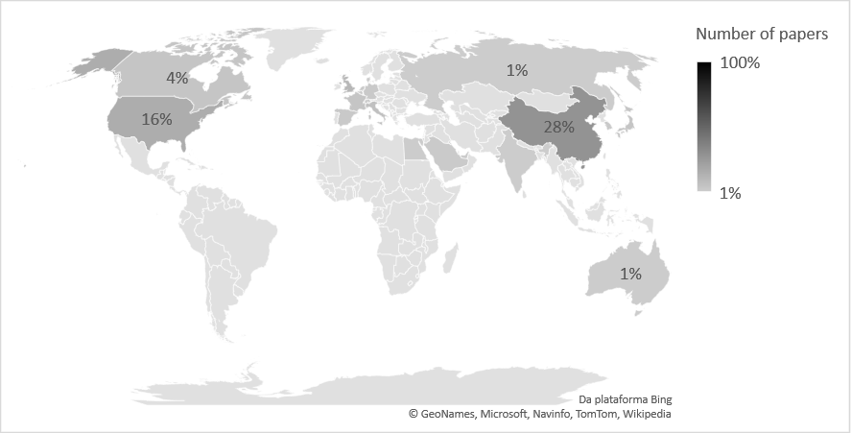
Fig. 1
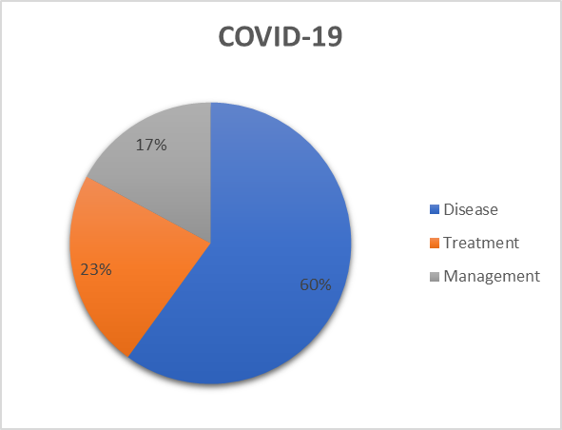
Fig. 2.
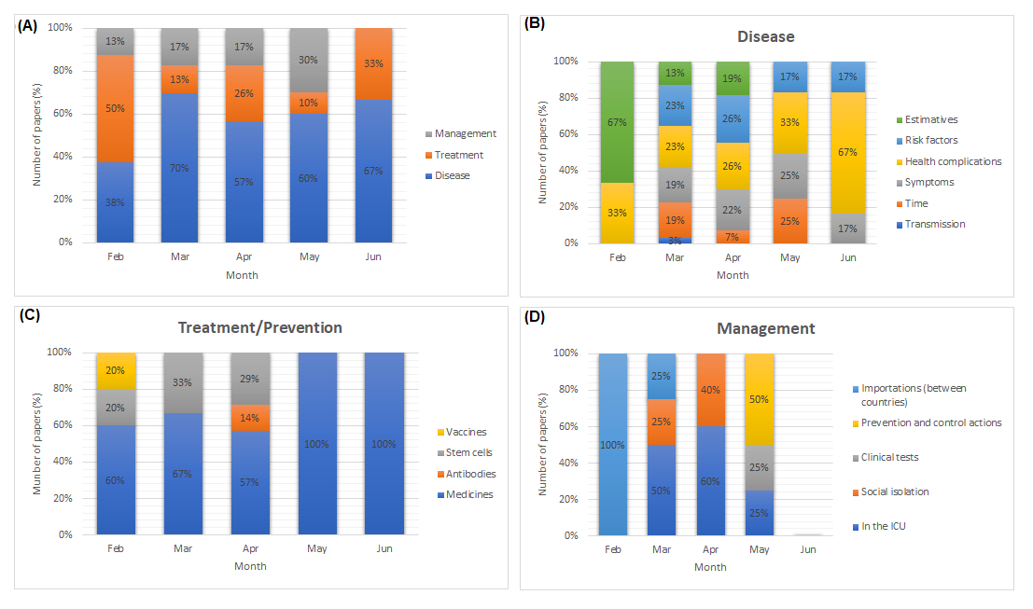
Fig. 3.
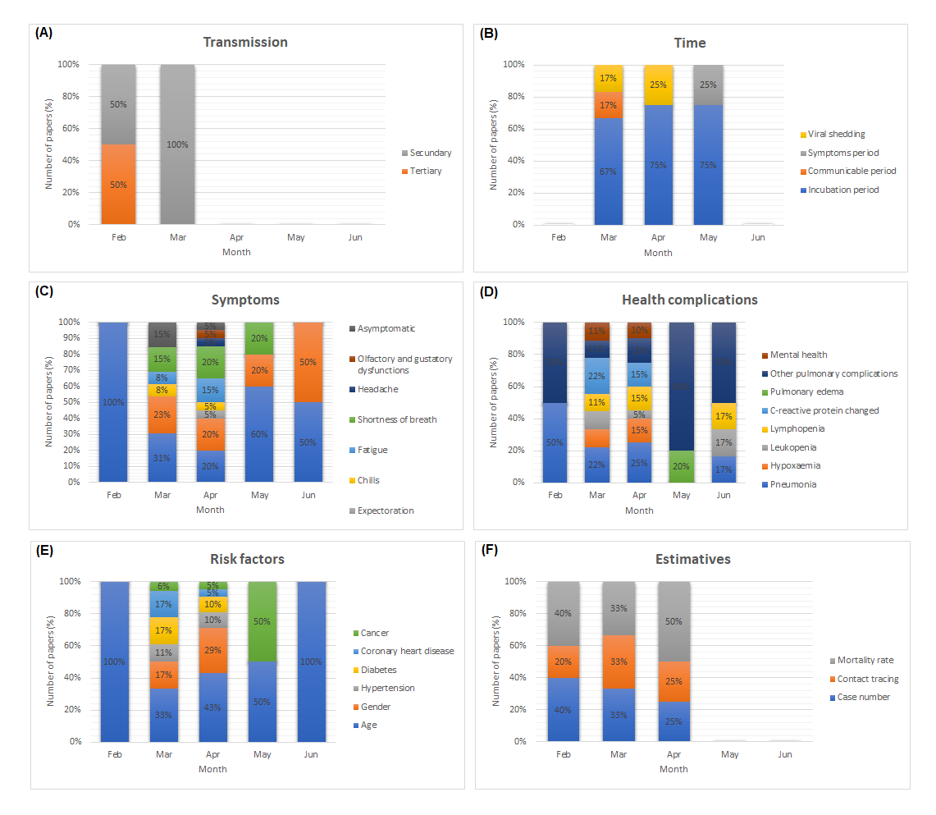
Fig. 4.
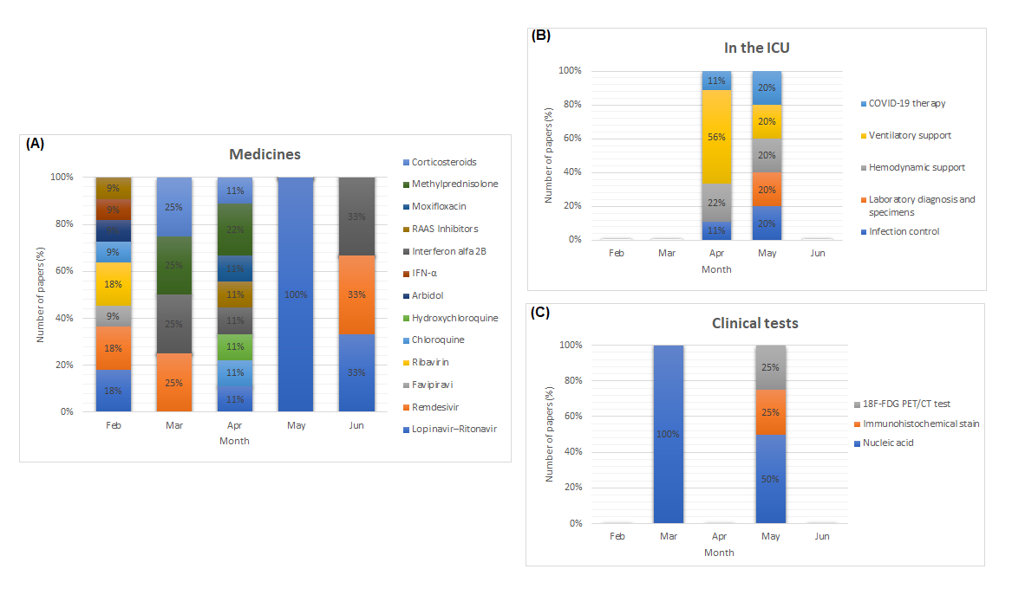
Fig. 5.

Supplementary Materials

Materials and Methods
Scientific Articles Prospecting
Scientific articles were selected from the Web of Science databases, a platform of indexed citations data, maintained by Clarivate Analytics, containing more than 34000 journals from different areas of knowledge (www.webofknowledge.com). The search was performed using the keyword “COVID-19” and the field “titles of articles”. Almost 10500 documents were found until the beginning of July 2020, being 3553 papers. The most cited articles in the scientific community, from February to June 2020, at least 40 citations, were selected for further analysis.
Scientific Articles Classification
The articles selected in the prospective step were classified into three levels of analytical detail: Macro, Meso, and Micro. In the Macro Analysis, the articles were grouped by countries, according to the authors of each work. In the Meso Analysis, the articles were classified according to the approach performed: disease, treatment/prevention, and management of COVID-19. In the Micro Analysis, a greater level of detail was performed for each driver of the Meso Analysis, in order to identify the main aspects of the COVID-19 scientific investigation. For some drivers, a second Micro Analysis was also performed (Table S1). Figure S1 shows the infographic of the taxonomies used for the classification of papers.

Fig. S1. Infographic of the classification levels of analysis of the most cited articles.
Each section of the figure corresponds to the approach reported in the articles at three levels: Macro, Meso, and Micro. The size of each level indicates the proportional quantity of articles with a focus on the respective classificatory taxonomy used.

Table S1 Taxonomies used for classification of COVID-19 papers
Meso-analysis | Micro-analysis I | Micro-analysis II
Disease | Transmission | Via droplets
 |  | Direct contact
 |  | Tertiary
 | Time | Incubation period
 |  | Communicable period
 |  | Symptoms period
 |  | Viral shedding
 | Symptoms | Fever
 |  | Cough (dry)
 |  | Expectoration
 |  | Chills
 |  | Fatigue
 |  | Shortness of breath
 |  | Headache
 |  | Olfactory and gustatory dysfunctions
 |  | Asymptomatic
 | Health complications | Pneumonia
 |  | Hypoxemia
 |  | Leukopenia
 |  | Lymphopenia
 |  | C-reactive protein changed
 |  | Pulmonary edema
 |  | Other pulmonary complications
 |  | Mental health
 | Risk factors | Age
 |  | Gender
 |  | Hypertension
 |  | Diabetes
 |  | Coronary heart disease
 |  | Cancer
 | Estimative | Case number
 |  | Contact tracing
 |  | Mortality rate
Treatment /Prevention | Medicines | Lopinavir–Ritonavir
 |  | Remdesivir
 |  | Favipiravir
 |  | Ribavirin
 |  | Chloroquine
 |  | Hydroxychloroquine
 |  | Arbidol
 |  | IFN-α
 |  | Interferon alfa 2B
 |  | RAAS Inhibitors
 |  | Moxifloxacin
 |  | Methylprednisolone
 |  | Corticosteroids
 | Vaccines
 | Antibodies | Convalescent plasma
 | Stem cells | Mesenchymal
Management of COVID-19 | In the ICU | Infection control
 |  | Laboratory diagnosis and specimens
 |  | Hemodynamic support
 |  | Ventilatory support
 |  | COVID-19 therapy
 | Social isolation
 | Prevention and control actions
 | Clinical tests | Nucleic acid
 |  | Immunohistochemical stain
 |  | 18F-FDG PET/CT test
 | Importations

